

[This Photo](https://twowritingteachers.org/2014/08/20/interactive-writing-dont-close-the-door/) by Unknown Author is licensed under [CC BY-SA-NC](https://creativecommons.org/licenses/by-nc-sa/3.0/)

PCS Connects Enrichment Activity for Middle School ELA

Writing Practice with a Focus on Introduction and Conclusion

Students can join an hour -long learning session, after school, to get some tips and practice with informational and argumentative writing. We will focus on writing good introductions and conclusions, as well as other parts of essay writing.

After the session, there will be a Canvas module available that students can access anytime to practice beyond the learning session.

**Dates:**

6th grade students: Monday, March 8th from 5:30-6:30

7th and 8th grade students: Tuesday, March 9th from 5:30-6:30

**Location:**

Virtual through the Teams platform

To attend click on the link beside the date and time assigned for your grade level.

6th grade 3/8, 5:30-6:30 [Click here to join the meeting](https://teams.microsoft.com/l/meetup-join/19%3ameeting_MzdlYmM2ZjEtMDUyNC00NjJmLTg1YTAtYjc1NmFjMmY0N2Zj%40thread.v2/0?context=%7b%22Tid%22%3a%22733c9305-39d7-461a-866f-fdf27bf3c7ff%22%2c%22Oid%22%3a%22bace3290-6b7e-4a55-9516-488cc9ca3e39%22%7d)

7th-8th grade 3/9, 5:30-6:30 [Click here to join the meeting](https://teams.microsoft.com/l/meetup-join/19%3ameeting_MTRhZWQwMGQtODhiYS00ZWZjLTg1NDItM2RiNmIwYmZhYWJj%40thread.v2/0?context=%7b%22Tid%22%3a%22733c9305-39d7-461a-866f-fdf27bf3c7ff%22%2c%22Oid%22%3a%22bace3290-6b7e-4a55-9516-488cc9ca3e39%22%7d)

Before the learning session date, you will need to access the Canvas module page at the link below and download or print out the two items under the “**Resources to Print or Download for Training Page”.** Once you click the link <https://pcsb.instructure.com/enroll/9T6G88>

you will be on your Canvas dashboard. Scroll down and click into to this module:

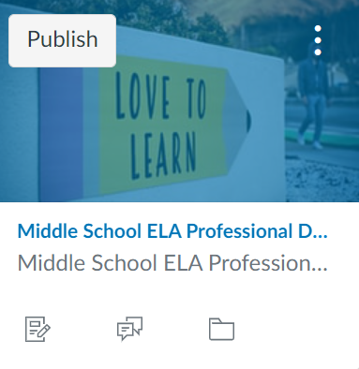The writing training will be informative but also interactive!

mmoduleodmodule

Parents are welcome to participate along with their student.